# **1.Introduction**

This report provides an overall documentation and understanding about Team JEEB’s Capstone Project. Our client is QUT Foundry. QUT Foundry is a department under QUT (Queensland University Technology). QUT Foundry tends to provide support to startups which has at least one QUT’s current students or alumni. To categorize QUT Foundry industry sector, it will likely to be in the education sector.

As mentioned above, QUT Foundry provide support to startups which has at least one QUT’s current students or alumni, support provided includes: financial support, resources support, mentoring program, networking session and others. The community founder of QUT Foundry mentioned that their business goals is to see startups success, helps QUT student to connect to the industry and assist business to find the right match of partnerships and employees, in order to assist all these growing startups and students, QUT Foundry provide a variety of programs and events to keep entrepreneurs and students up to date and the bonding between each other. QUT Foundry offers a co-working space for entrepreneurs and staff, most events and programs are held in this co-working space.

Team JEEB’s was assigned to QUT Foundry in the case of helping QUT Foundry to develop their external website (under the supervision of QUT Marketing Department) and also a tailored made CMS (Content Management System) which allows QUT Foundry Staff to be able to write and post content to the web page and also alter the content such as slideshow (carousel), social media links and others. QUT Foundry Staff will also be able to use this website as a simplified version of CRM (Customer Relationship Management System) to assist marketing segmentations and automate the process of sending newsletters that draw people to events and improve the relationships between entities. There are more functionalities and features requested and discussed which will include in later of this document.

This project scope is a Web Application Project and organised in the way that make students able to finish the requested work in Capstone Phase 1 and Capstone Phase 2.

This project impacts QUT Foundry in the way that improve the exposure to target audience and increase the competitive advantage between co-working space industry. Other major and minor impacts that cause by this project will be, target audience will be able to differentiate the difference between QUT Blue Box and QUT Foundry which is hardly to differentiate before the implementation of this project as QUT Foundry website is not accessible by public and QUT Bluebox is the one that power QUT Foundry at the moment but they are two different entities, QUT Foundry can have a more professional branding which allows QUT Foundry to optimise and organise it website freedomly (under the supervision of QUT Marketing Department) and enables its members and users a more easier way to access to services provide by QUT Foundry, for example: Booking QUT HotPops, Booking Working Space and Work Matchup, the last but not least impact will be increasing the efficiency and eligibility of QUT Foundry Community Managers workload by automating internal process, minimizing human error, remove redundant expenses.

In order to provide a service to authenticate the users of this website, Team JEEB discuss with various stakeholders (QUT HiQ, QUT Foundry, Project Supervisor) and provide the most simple and secure way to authenticate user. For technical context of the application and its inputs, after discussion with the internal team members of Team JEEB and the approval of client, Team JEEB plan to use Node.js (React Library) Technology to develop this project. Due to the high flexibility needed by this project and also the dynamic level of the element of the webpage, we decide that Node.js (React) is the most suitable technology to develop this project. The community support of Node.js (React) developers is also another persuasive reason that we chose Node.js (React) to be the technology to develop this Web Application Project. For the Database, MYSQL was selected due to the stability. More technologies context and inputs will discussed in the later part of this report. We appreciate all efforts of each and every stakeholders input into this capstone project.

# **2. Project Scope and Plans**

# The whole capstone project can be considered as a two semesters working time, which is also known as Capstone Phase 1 and Capstone Phase 2. We was assigned to this project around Week 7, as the previous project that were assigned to us doesn’t suit our team’s skill sets and so was turned back and started this project late. Our team understand that we started this project in the late semester but still tries our best to provide the most appropriate and follow the Agile development framework to ensure our product meets client's expectation. A mitigation strategy to this problem is to speed up the planning and development process and at the same time constantly discuss with client and update the project progress and information to them, and request for advance necessary document. In the end of this semester we promise the quality of the end-product with our client - QUT Foundry.

Team JEEB breakdown the project into two main parts, the Planning Part and the Actual Development Part. All processes are done following the actual requirements of Agile Framework and also the main focus is to fulfil the expectations of our Client. Due to the number of involved stakeholders and business goals of our client, this project was given a variety of functionalities and features which need to be established in order to reach these goals. However, as a professional team, Team JEEB provide consultation and address problems for our client and later propose a complete project plan that includes all functionalities and features discussed to help our client meets its business goals and solutions to problems. This project plan also includes how and when Team JEEB is going to implement the particular function and the delivery or release dates. Team JEEB prioritise functionalities and features due to the requirement of the client or the development workflow. For example, QUT Foundry would like to have a exclusive ‘Mentor Program Booking Service’, which can’t be accessed from outsiders (not QUT Student / Alumni), in order to deliver such a service to QUT Student / Alumni this website should be able to identify who this user is, in other words a identification service, in this case, ‘Login / Logout’ would be prioritise.Due to client highly prioritised `QUT Hotpops Booking System` we designed the plan in a way that also prioritize the implementation of ‘QUT Hotpops Booking System’ over other functionalities and features. Team JEEB documented more specific plannings on Sprint Plan and Release Plan.

# 

# **2.1 Project Plan**

**Release Plan Summary:**

The table 1.0 below shows the summary for the overall release plan of the Capstone project, which includes the involved user story ID, the goals for each release plan as well as the estimated time cost for each release plan. The whole project consists of three release plan of the development phase.

The first release plan is focus on delivering the maximum business value to the QUT foundry within a relatively short development phase. Based on the first release plan, Team JEEB will focus on achieving the Booking Systems for QUT foundry and administer management feature for the second release plan. The last release plan is aimed at releasing the online communicate features which enable users to send message via web page directly. Also, the third release plan will focus on achieving the Editing website content feature which enable admisinters to edit the content of the web page easily and straightforwardly.

|  |  |  |  |
| --- | --- | --- | --- |
| **Release Plan** | **Goals for this release** | **Involved  User Story ID** | **Estimated  hours** |
| **Release  pan I** | Delivering the maximum business value to QUT foundry within a relatively short time period of development. The features will be focused on in this release includes:   * Information Present   Users can view a comprehensive and detailed information about the QUT foundry as well as the offers and vents that are provided by QUT foundry.   * Log in Service   Users can register the membership for QUT foundry. Also, the different stakeholders can log in their account to the QUT foundry page. | **Information Present:**  S01, S02, S03, S04    **Log in Service:**  S07, S08 | 95 hours |
| **Release plan II** | Releasing the dynamic web page, enable users can have interaction with QUT foundry web page.   * Booking Service   Which can enable users to book the Hot POPs and co-working space with QUT foundry via web page, the members of QUT foundry can request the 24 hours access of the QUT foundry space.   * Hot Pops Administer Management   From the administer side, administers are able to handle the requests for booking of Hot POPs store via the web page. | **booking Service:**  S05, S06, S10    **Hot Pops Administer Management:**  S09 | 116 hours |
| **Release plan III** | Focus on satisfies all  stakeholders’ needs includes:   * Editing website content feature   QUT Foundry Staffs are able to edit content to the web page, they can easily update the content on the web page.   * Community feature   enabled QUT foundry memberships to communicate with each other’s and can find the people who have the same goals or want to work together. | **Editing website content feature:**  S14  **Community feature:**  S11, S12, S13 | 133 hours |

Table 1.0

# **Delivery Schedule** **-** The table 1.1 below shows the delivery schedule of the whole release plan. All the release plan will be due in IFB 399. Team JEEB has finished the negotiation of scope for the project with all involved stakeholders and formulated the release plan and sprint plan for the next phase. In the current situation, Team JEEB is making progress to achieve the release plan I. Team JEEB has finished the high fidelity prototypes and the ERD diagram for basic function of backend database.

|  |  |  |  |  |  |  |  |  |  |  |
| --- | --- | --- | --- | --- | --- | --- | --- | --- | --- | --- |
| week1 | week2 | Week 3 | Week 4 | Week 5 | Week 6 | Week 7 | Week 8 | week 9 | ... | Week 13 |
| Sprint 1 | | | | Sprint 2 | | | | Sprint 3 | | |
| Release 1 | | | | Release 1 | | | | Release 3 | | |

Table 1.1

**User Story backlog -** To achieve the final goals of the projects and meet the client’s needs. Team JEEB creates 14 user stories which are all based on the INVEST theory and the priority is follow the MosCoW principle according to the clients’ requirements. The below table 1.2 shows the detailed user stories which are be categorized into different themes of feature. The priority for each user story is based on the client’s needs.

|  |  |  |  |  |
| --- | --- | --- | --- | --- |
| **Themes** | **ID** | **Title** | **User Story** | **Priority** |
| **Information Present** | 1 | Event information | As a student I want to know the event/training workshop that hold by QUT foundry so that I can attend the event that I am interested in. | Must |
| 2 | Funding Information | As a starter I want to know the information of funding that are provided by QUT foundry, so that I can apply for getting funding to support my business. | Must |
| 3 | QUT Foundry Information | As a student/starter/entrepreneur I want to know the information about QUT foundry, so that I can understand more about QUT Foundry. | Must |
| 4 | HOT POPS Information for (public) | As a student/starter/entrepreneur I want to check the HOT POPS so that I can know the upcoming events on the HOT POPS store. | Must |
| **Booking Service** | 5 | Booking Hot pop (private) | As an entrepreneur I want to book the session of Hot Pop store for my new business so that I can test my new business in the QUT campus. | Must |
| 6 | Space Booking | As a member of QUT foundry I want to book a space with QUT foundry so that I can hold the meeting for my business with the help of QUT foundry | Should |
| 10 | Request for room assessing | As a starter/entrepreneur  I want to send a request for accessing to the place of QUT foundry in 24/7  So that I can go there to work with my colleague anytime. | Could |
| **Log in Service** | 7 | Register Membership | As a starter I want to become a member of QUT foundry so that I am able to use the services provided by QUT | Must |
| 8 | Login | As a QUT foundry members I want to login to the system so that I can use the services on the online platform. | Must |
| **Hot Pops Administer**  **Management** | 9 | Handle Hot Pops request | As a QUT foundry administrator  I want to handle the request of booking for the Hot Pops via the website, so that I can manage hot pops store easier. | Should |
| **Community** | 11 | Sharing idea | As a starter I want to share my new idea with someone so that we can work together to innovate a new service or product | Should |
| 12 | Communication | As a member of the QUT foundry  I want to chat with my colleague online So that we can share our idea to each other’s. | Could |
| 13 | Match up people | As a leader of the start-up company  I want to find and invite people who have the skill set that I am looking for to join my new project so that I can have more people to work on the new project | Should |
| **Editing website content** | 14 | Content Editing | As a QUT Foundry Owner I want to be able to update the web contents  So that user can know the latest information about QUT Foundry. | Should |

Table 1.2

2.2 Feasibility Analysis

After receiving this project from IT Capstone Team, besides holding meeting every 2 weeks with our client we also research on the domain about the problem and challenges we are facing and prepare for resources we need in the future.

In the technical aspect, web application project normally involve front-end and back-end development, in this project we tend to create a Web based Content Management System and Customer Relationship Management System. After discussion with our client, the first thing that take into consideration by our client is one of the world’s famous CMS - Wordpress. Wordpress is well-known of the big community support and friendly User Interface. Wordpress was coded in PHP and works well with MYSQL Database. However due to the requested flexibility and the degree of customisation requested by our client, we decide to create a more flexible CMS for them. The other reason that we choose to develop the website and the systems without using Wordpress that was known to power more than 32% of website in the internet is because we have to follow exactly to the User Interface Style Guide provided by QUT Marketing, as QUT Foundry (our client) acts as a department in QUT any exposure will be representing QUT, so in the marketing perspective consistency is very important. Wordpress works well with Wordpress template but not with such high degree of custom designed web page, other than that we also requested by our client to integrate Google Calendar Synchronisation, Room/HotPops Booking System and HiQ Private CMS (Glassdoor) it is impossible to integrate all these services and APIs with Wordpress, so Wordpress dosen’t seems to meet our development expectation.

We receive the full version of QUT UI Style Guide from our client and after analysing and researching on QUT sites we notice that QUT Career Hub site is quite similar to what our client expectation. We did research on this site and found out that this website was built with the following technologies: Frameworks: ASP.NET 4.0, AngularJS and Web Server: IIS 8. Which make sense that Microsoft provides premium support to businesses all around the world, and both of this technologies are Microsoft product, from the perspective of QUT, QUT would not need to worry about the support of these technologies as Microsoft is a stable and established world-wide company. We then start thinking about the support provide by the community is very important told by our client that their budget on this project is very limited, and our developers are more skilled in Node.js development so we research about the statistic of Node.js usage results are shown in Figure 1 and Figure 2. Despite a lot of frameworks such as Express / Jade that works well with Node.js in out in the market we wouldn’t need to reinvent the wheel.

Our client are relatively busy so most of the time we update them using Slack and formal e-mail. We manage to develop a MVP Prototype and show them and ask for feedbacks, gratefully the prototype met client’s expectation. One of the challenge in developing this project is QUT Foundry would like to identify is the user from QUT as some services like Hotpops is only available for QUT Students, but after discussion QUT can’t grant access for us to access to students database, instead we try different approach. We contacted HiQ and have a meeting with them to ask for API to Glassdoor system for integration purpose, we are still waiting for the reply. It’s hard to get such access, as they are very sensitive data to QUT, so we come out with a solution, request for QUT e-mail in the registration phase and in order to successfully complete the registration the user would need to input a authentication code which was generated by our systems and send to their QUT e-mail. With this solution we can ensure that the account was registered by a QUT student as only QUT student have access to their responding QUT e-mail. This e-mail authentication access code solution not just address the identification problem but also brings benefits to harden the security.

Our client will only be able to provide a server only on the Phase 2, so in between we tested the implementation and abit of coding in localhost server. Before the end of Capstone Phase 1 we proposed a detailed release plan and sprint plan to our client ensuring that all stakeholders are on the same page, and also invite them to our final presentation.

# **3. The Artefact (Software Project)**

1. **Architecture**

Refer to the diagram 1 which is attached in the Appendix, It shows how the application works behind the scene and what kind of technology our development team used to develop the web application. The Web Server is responsible to send the webpage to the client and sending client request to application server. On the other hand, the application server is responsible to handle the client request which received from the web server. Such as inserting the customer information to the database or getting all the Qut Foundry event information from the database to display it on the website.

1. **Technical Description**

The diagram 2 describes the whole structure of the database for storing or retrieving information which related to QUT foundry. After we hearing the requirement from our client, we found that are lots of relationship between all the information we need to store to the database. Such as Group with Member, Member with Event, Group with event.

There are four class which are extremely important for this application. It includes Member, Event, Hot pop and Group class. Member class is used to store the information about Qut foundry members. Event class stores all the event information which held by QUT foundry. Hot pop class stores all the hot pops booking information. Finally, Group class stores all the match up group information for online chatting function. All of these class are used to provide the main feature for the web application. Such as booking hot pops, match up people to groups and register as a QUT foundry member.

When the client want to use the service which provided by QUT foundry, they will need to register as a new member on the website. In this case, the application server will insert the information to member table for recording as a new member. If the user want to login to the website, the application server will match the password and username to all the information that existed in the member table. The reason we decide to use relational database is that it can maintain the information consistency. For example, a member can join at lease zero to many match up groups. On the other hand, a group can be joined by at least one to many members. It is a one to many relationship. If we are using NoSQL database to store the data like that, the user updated their own information to the database. It might lead to information incorrect to other table. In this case, if the member change their personal information, if will not effect to the other table.

1. **Functionality**

In this stage, our backend developer has already made a simple server-side application to test that can receive HTTP Request and send HTTP Response to the client for finishing some of the client request. In this case, there are lots of the user stories required to retrieve the information from database to display the information on the webpage. Such as displaying event information, displaying Hot pops information and register membership. The server-side application is already able to send the database information to the client and receive the client request to update the information to the database. Diagram 3 illustrated that client can send a http request to the following route to do some specific action to the database. For example, the user want to register to be a member of QUT foundry. When the register page is developed in the future, we will connect the website to the backend server. User can send their information via the website and submit it. The information will automatically transfer to the server port then save into the member table in foundry database.

1. **Quality and Metrics**

In the current stage, our website is not developed yet. In order to test out the backend server works as we expected. Our backend developer used an application called postman to test out the server response. In diagram 4, it is a screen shot for using postman to send a simulated http request to the server application. It sent a Json format file to the server application, the server application will put this Json format data to save it to the database. If the insertion is success, the server will reply a message for showing insert successfully to the client. In this case, it listed at the bottom of the postman user interface. Diagram 5 illustrated that our information has successfully inserted to the member table in the database. In the future we would perform Unit Test in testing the input of data into the database and Automate Testing using Selenium to create scripts that test the UI and UI inputs, before releasing the end-product to our client. For the whole development process we use GitHub to perform a source control by creating branches for every component changing and edit of the codes. Before deploying the whole complete application to the live server we perform testing and implementation on the development server.

# **4.Contribution**

Contribution Summary:

In this project positions are assigned as follow:

Team JEEB

N10055479 – Zijun Lu (Scrum Master)

N9845097- Ka Long Lee (Developer)

N10067221 – Hong Song Kua (Product Owner)

N10050256 – Tsz Hei Lau (Developer)

All of us in this team agree with the equally distribution manner. We submit journal that indicates our work in the fortnightly meeting with our tutor. Scrum Master was responsible with writing Meeting Minutes and ensuring the whole development process follows the Agile Framework, Zijun Lu use Asana to create work appointment and keep all of us in the team on track and also acted professionally in assigning work on each members regarding to their skillsets. Hong Song Kua who is the Product Owner of this project, responsible in communicating with stakeholders, he scheduled meeting and constantly update all stakeholders with the latest progress of the planning and development, ensuring every stakeholders have a neutral understanding on the process and progress. Always available in the meeting and when there’s any unclear or misunderstanding Hong Song Kua always clarify and identify them correctly and explain to all involved stakeholders. Developer, Ka Long Lee who is responsible in developing and testing the product manage to develop the application on time even though we started late. He uses Github professionally and source control the contribution and committing and merging branches. He constantly conduct research and develop on his localhost to test the MVP prototype such as setting up connection between database and web server and testing the APIs. Tsz Hei Lau, another Developer of this project, always ensure the prototype meets the expectation of the client, and able to perform the transition from low-fidelity to high fidelity which visualize the idea of the client and demonstrate in front of them during each meetings.

While developing the prototype, Tsz Hei Lau ensures that the design is following QUT’s Style Guide and the consistency of the design, if there’s any unclear or unsure about the design he always clarifies with the client and work until the design meets the expectation.

# **5.Appendix**

## 

Diagram 1. Logical and Physical Diagram

## 

Diagram 2. Entity Relationship diagram

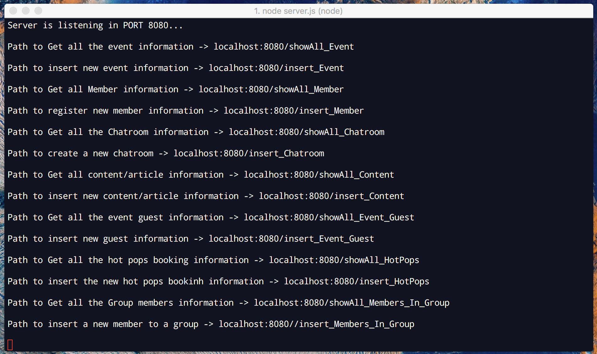

Diagram 3. Server Live Testing on Localhost

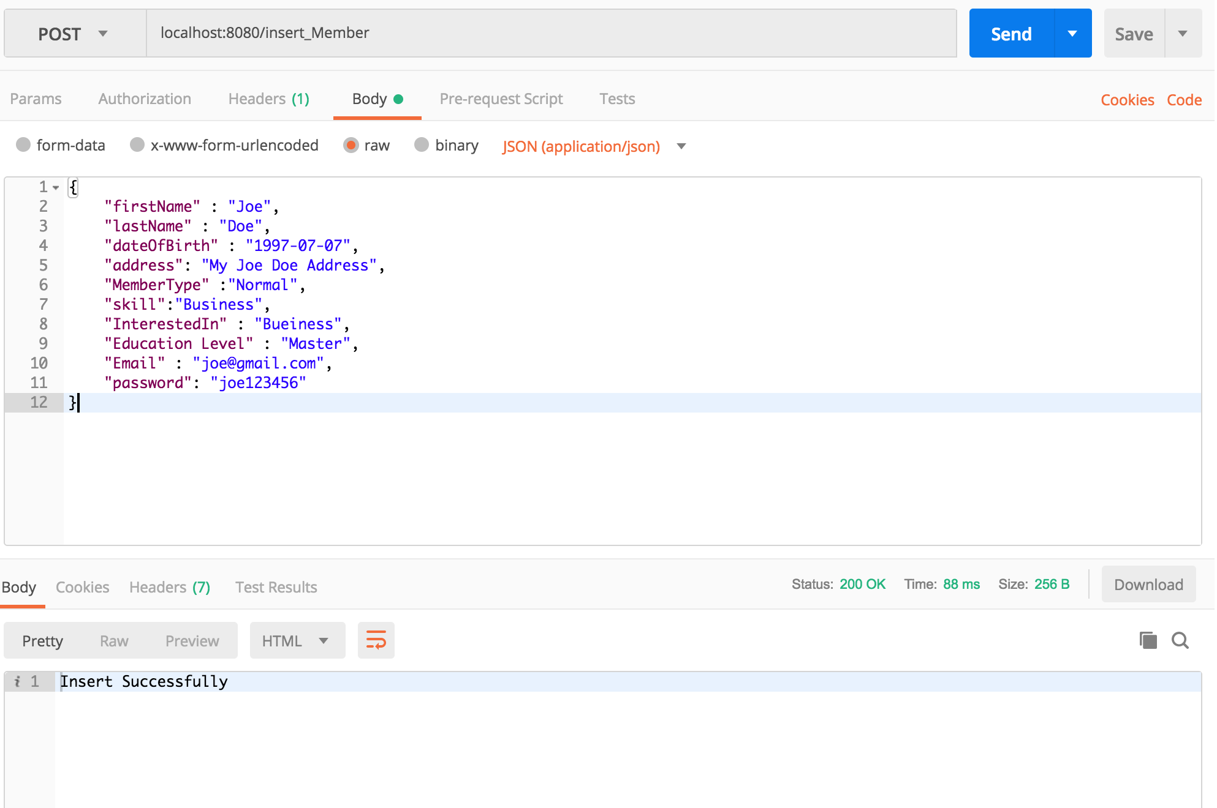

Diagram 4. PostMan package sending Testing interface

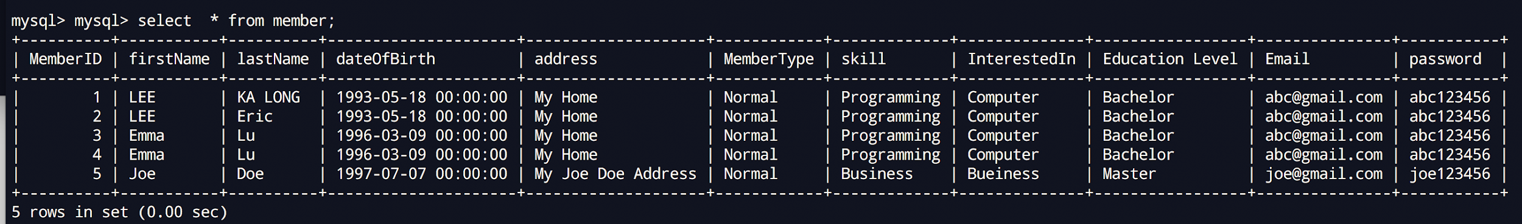

Diagram 5 MySQL request result

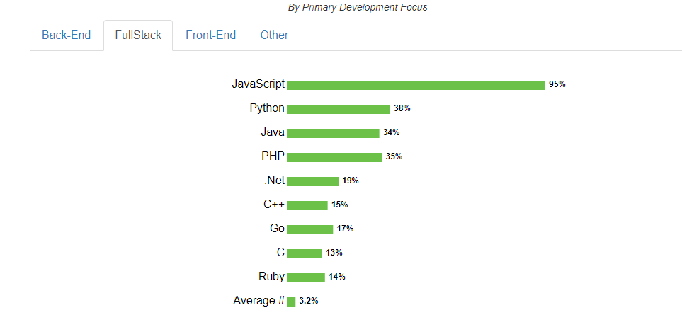

Figure 1. (Javascript usage in FullStack development compared to other languages) - [Link](https://nodejs.org/en/user-survey-report/)

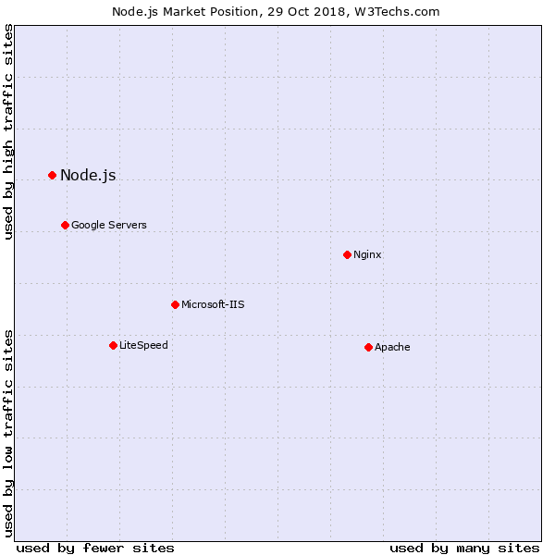

Figure 2. (Nodejs Market Position) - [Link](https://w3techs.com/technologies/details/ws-nodejs/all/all)